AI ASSISSTED CODE – 9
HALL NO:2403A52141
BATCH NO:06

TASK-1:
Basic Docstring Generation
• Write python function to return sum of even and odd numbers in the given list.
• Incorporate manual docstring in code with Google Style
• Use an AI-assisted tool (e.g., Copilot, Cursor AI) to generate a docstring describing
the function.
• Compare the AI-generated docstring with your manually written one

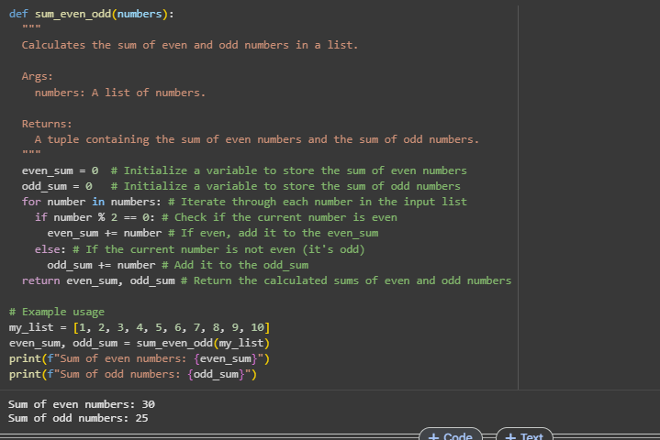
COMMENTS:
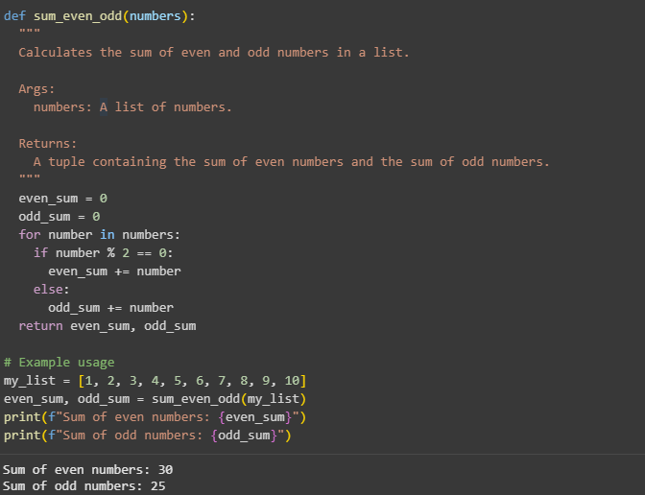
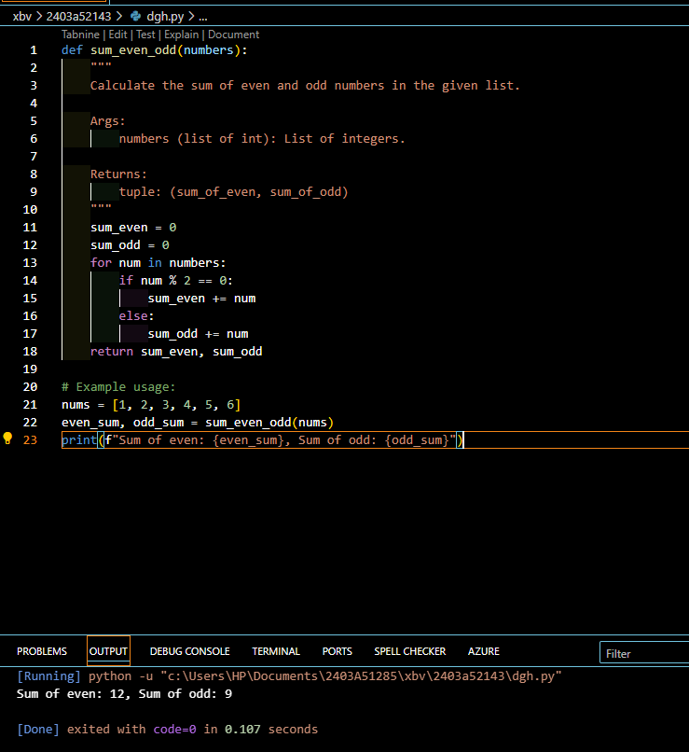
COMMENTS:
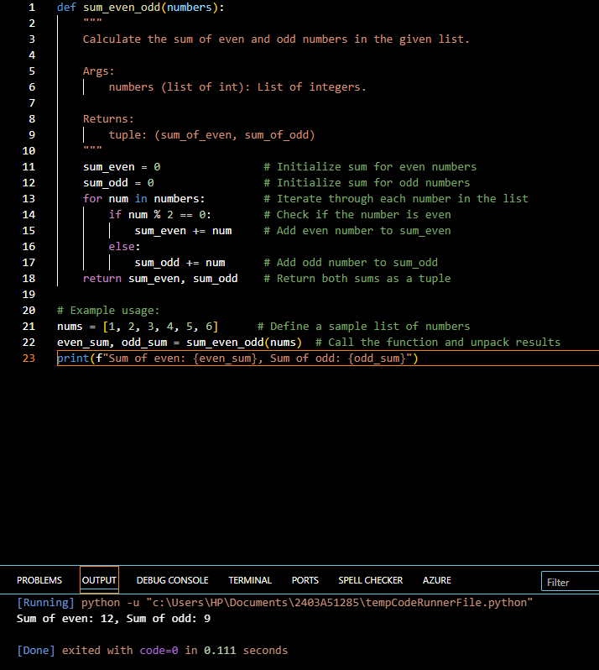
CODE EXPLANATION:
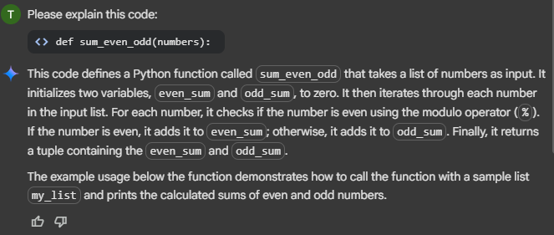

TASK-2:
Automatic Inline Comments
• Write python program for sru_student class with attributes like name, roll no.,
hostel_status and fee_update method and display_details method.
• Write comments manually for each line/code block
• Ask an AI tool to add inline comments explaining each line/step.
• Compare the AI-generated comments with your manually written one

class sru_student:
"""
Represents a student at SRU with attributes for name, roll number, and hostel status.
Includes methods to update fees and display student details.
"""
def __init__(self, name, roll_no, hostel_status):
"""
Initializes a new sru_student object.

Args:
name (str): The name of the student.
roll_no (str): The roll number of the student.
hostel_status (bool): True if the student is a hosteller, False otherwise.
"""
self.name = name
self.roll_no = roll_no
self.hostel_status = hostel_status
self.fees_paid = 0 # Initialize fees paid to 0

def fee_update(self, amount):
"""
Updates the amount of fees paid by the student.

Args:
amount (float): The amount of fees to add to the fees paid.
"""
if amount > 0:
self.fees_paid += amount
print(f"Fees updated for {self.name}. Total fees paid: {self.fees_paid}")
else:
print("Invalid amount. Please provide a positive value for fee update.")

def display_details(self):
"""
Displays the details of the student.
"""
print("\n--- Student Details ---")
print(f"Name: {self.name}")
print(f"Roll Number: {self.roll_no}")
print(f"Hostel Status: {'Hosteller' if self.hostel_status else 'Day Scholar'}")
print(f"Fees Paid: {self.fees_paid}")
print("-----------------------")

# Example Usage:
student1 = sru_student("Alice Smith", "SRU12345", True)
student2 = sru_student("Bob Johnson", "SRU67890", False)

student1.display_details()
student2.display_details()

student1.fee_update(5000)
student2.fee_update(3000)
student1.fee_update(2000) # Another fee update for student1

student1.display_details()
student2.display_details()

COMMENTS:
class sru_student:
"""
Represents a student at SRU with attributes for name, roll number, and hostel status.
Includes methods to update fees and display student details.
"""
def __init__(self, name, roll_no, hostel_status):
"""
Initializes a new sru_student object.

Args:
name (str): The name of the student.
roll_no (str): The roll number of the student.
hostel_status (bool): True if the student is a hosteller, False otherwise.
"""
self.name = name # Assign the provided name to the object's name attribute
self.roll_no = roll_no # Assign the provided roll number to the object's roll_no attribute
self.hostel_status = hostel_status # Assign the provided hostel status to the object's hostel_status attribute
self.fees_paid = 0 # Initialize fees paid to 0 for a new student

def fee_update(self, amount):
"""
Updates the amount of fees paid by the student.

Args:
amount (float): The amount of fees to add to the fees paid.
"""
if amount > 0: # Check if the update amount is positive
self.fees_paid += amount # Add the valid amount to the fees_paid
print(f"Fees updated for {self.name}. Total fees paid: {self.fees_paid}") # Print a confirmation message
else:
print("Invalid amount. Please provide a positive value for fee update.") # Print an error message for invalid input

def display_details(self):
"""
Displays the details of the student.
"""
print("\n--- Student Details ---") # Print a header for student details
print(f"Name: {self.name}") # Print the student's name
print(f"Roll Number: {self.roll_no}") # Print the student's roll number
print(f"Hostel Status: {'Hosteller' if self.hostel_status else 'Day Scholar'}") # Print the hostel status (Hosteller or Day Scholar)
print(f"Fees Paid: {self.fees_paid}") # Print the total fees paid by the student
print("-----------------------") # Print a footer for student details

# Example Usage:
student1 = sru_student("Alice Smith", "SRU12345", True) # Create the first student object
student2 = sru_student("Bob Johnson", "SRU67890", False) # Create the second student object

student1.display_details() # Display details of the first student
student2.display_details() # Display details of the second student

student1.fee_update(5000) # Update fees for the first student
student2.fee_update(3000) # Update fees for the second student
student1.fee_update(2000) # Another fee update for the first student

student1.display_details() # Display updated details of the first student
OUTPUT:
--- Student Details ---
Name: Alice Smith
Roll Number: SRU12345
Hostel Status: Hosteller
Fees Paid: 0
-----------------------

--- Student Details ---
Name: Bob Johnson
Roll Number: SRU67890
Hostel Status: Day Scholar
Fees Paid: 0
-----------------------
Fees updated for Alice Smith. Total fees paid: 5000
Fees updated for Bob Johnson. Total fees paid: 3000
Fees updated for Alice Smith. Total fees paid: 7000

--- Student Details ---
Name: Alice Smith
Roll Number: SRU12345
Hostel Status: Hosteller
Fees Paid: 7000
-----------------------

--- Student Details ---
Name: Bob Johnson
Roll Number: SRU67890
Hostel Status: Day Scholar
Fees Paid: 3000

------

class SRUStudent:
def __init__(self, name, roll_no, hostel_status):
self.name = name # Student's name
self.roll_no = roll_no # Student's roll number
self.hostel_status = hostel_status # Hostel status (True/False or string)
self.fee_paid = False # Fee payment status

def fee_update(self, status):
"""
Update the fee payment status.
Args:
status (bool): True if fee is paid, False otherwise.
"""
self.fee_paid = status

def display_details(self):
"""
Display the student's details.
"""
print(f"Name: {self.name}")
print(f"Roll No.: {self.roll_no}")
print(f"Hostel Status: {self.hostel_status}")
print(f"Fee Paid: {'Yes' if self.fee_paid else 'No'}")

# Example usage:
student1 = SRUStudent("Alice", 101,"Yes")
student1.fee_update(True)
student1.display_details()
COMMENTS:
class SRUStudent:
def __init__(self, name, roll_no, hostel_status):
self.name = name # Assign the student's name
self.roll_no = roll_no # Assign the student's roll number
self.hostel_status = hostel_status # Assign the student's hostel status
self.fee_paid = False # Initialize fee payment status as False

def fee_update(self, status):
"""
Update the fee payment status.
Args:
status (bool): True if fee is paid, False otherwise.
"""
self.fee_paid = status # Update the fee payment status

def display_details(self):
"""
Display the student's details.
"""
print(f"Name: {self.name}") # Print the student's name
print(f"Roll No.: {self.roll_no}") # Print the student's roll number
print(f"Hostel Status: {self.hostel_status}") # Print the hostel status
print(f"Fee Paid: {'Yes' if self.fee_paid else 'No'}") # Print fee payment status

# Example usage:
student1 = SRUStudent("Alice", 101,"Yes") # Create a student object
student1.fee_update(True) # Update fee status to paid
student1.display_details() # Display student details

OUTPUT:
Name: Alice
Roll No.: 101
Hostel Status: Yes
Fee Paid: Yes

CODE EXPLANATION:
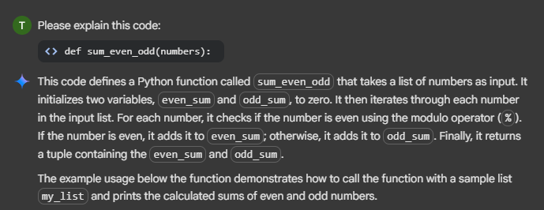

TASK-3:
Write a Python script with 3–4 functions (e.g., calculator: add, subtract, multiply,
divide).
• Incorporate manual docstring in code with NumPy Style
• Use AI assistance to generate a module-level docstring + individual function
docstrings.
• Compare the AI-generated docstring with your manually written one

def add(x, y):
"""Adds two numbers."""
return x + y

def subtract(x, y):
"""Subtracts the second number from the first."""
return x - y

def multiply(x, y):
"""Multiplies two numbers."""
return x * y

def divide(x, y):
"""Divides the first number by the second. Returns an error message if the divisor is zero."""
if y == 0:
return "Error: Division by zero is not allowed."
return x / y

# Example usage:
num1 = 10
num2 = 5

print(f"{num1} + {num2} = {add(num1, num2)}")
print(f"{num1} - {num2} = {subtract(num1, num2)}")
print(f"{num1} * {num2} = {multiply(num1, num2)}")
print(f"{num1} / {num2} = {divide(num1, num2)}")
print(f"{num1} / 0 = {divide(num1, 0)}") # Example of division by zero

COMMENTS:
def add(x, y):
"""Adds two numbers."""
return x + y # Return the sum of x and y

def subtract(x, y):
"""Subtracts the second number from the first."""
return x - y # Return the difference between x and y

def multiply(x, y):
"""Multiplies two numbers."""
return x * y # Return the product of x and y

def divide(x, y):
"""Divides the first number by the second. Returns an error message if the divisor is zero."""
if y == 0: # Check if the divisor is zero
return "Error: Division by zero is not allowed." # Return an error message if division by zero
return x / y # Return the result of the division

# Example usage:
num1 = 10 # Define the first number
num2 = 5 # Define the second number

print(f"{num1} + {num2} = {add(num1, num2)}") # Call add function and print the result
print(f"{num1} - {num2} = {subtract(num1, num2)}") # Call subtract function and print the result
print(f"{num1} * {num2} = {multiply(num1, num2)}") # Call multiply function and print the result
print(f"{num1} / {num2} = {divide(num1, num2)}") # Call divide function and print the result
print(f"{num1} / 0 = {divide(num1, 0)}") # Example of division by zero, call divide and print the result
OUTPUT:
10 + 5 = 15
10 - 5 = 5
10 * 5 = 50
10 / 5 = 2.0
10 / 0 = Error: Division by zero is not allowed.

def add(a, b):
"""Return the sum of a and b."""
return a + b

def subtract(a, b):
"""Return the difference of a and b."""
return a - b

def multiply(a, b):
"""Return the product of a and b."""
return a * b

def divide(a, b):
"""Return the quotient of a divided by b. Handles division by zero."""
if b == 0:
return "Error: Division by zero"
return a / b

# Example usage:
x = 10
y = 5
print("Add:", add(x, y))
print("Subtract:", subtract(x, y))
print("Multiply:", multiply(x, y))
print("Divide:", divide(x, y))
COMMENTS:
def add(a, b):
"""Return the sum of a and b."""
return a + b # Add a and b, return the result

def subtract(a, b):
"""Return the difference of a and b."""
return a - b # Subtract b from a, return the result

def multiply(a, b):
"""Return the product of a and b."""
return a * b # Multiply a and b, return the result

def divide(a, b):
"""Return the quotient of a divided by b. Handles division by zero."""
if b == 0: # Check if b is zero to avoid division error
return "Error: Division by zero" # Return error message if b is zero
return a / b # Divide a by b, return the result

# Example usage:
x = 10 # Assign value 10 to x
y = 5 # Assign value 5 to y
print("Add:", add(x, y)) # Print result of add function
print("Subtract:", subtract(x, y)) # Print result of subtract function
print("Multiply:", multiply(x, y)) # Print result of multiply function
print("Divide:", divide(x, y)) # Print result of divide function
OUTPUT:
Add: 15
Subtract: 5
Multiply: 50
Divide: 2.0

CODE EXPLANATION:
